PME 3433 MACHINE DESIGN Nov. 09, 2015

(open book)

1. The failure theories for ductile materials under static loading described in Chapter 5 consist of two theories, namely, (1) Maximum Shear Stress Theory; (2) Distortion Energy Theory. For brittle material, Maximum Normal Stress Theory (MNST) can be used, what is WNST? (3%) Why MNST cannot be used for ductile materials? (7%)
2. The following figure shows a vise-grip, please model it as a four-bar linkage and draw free-body diagram and derive an equation to describe the relation between the input force and the output clamping force. (25%)

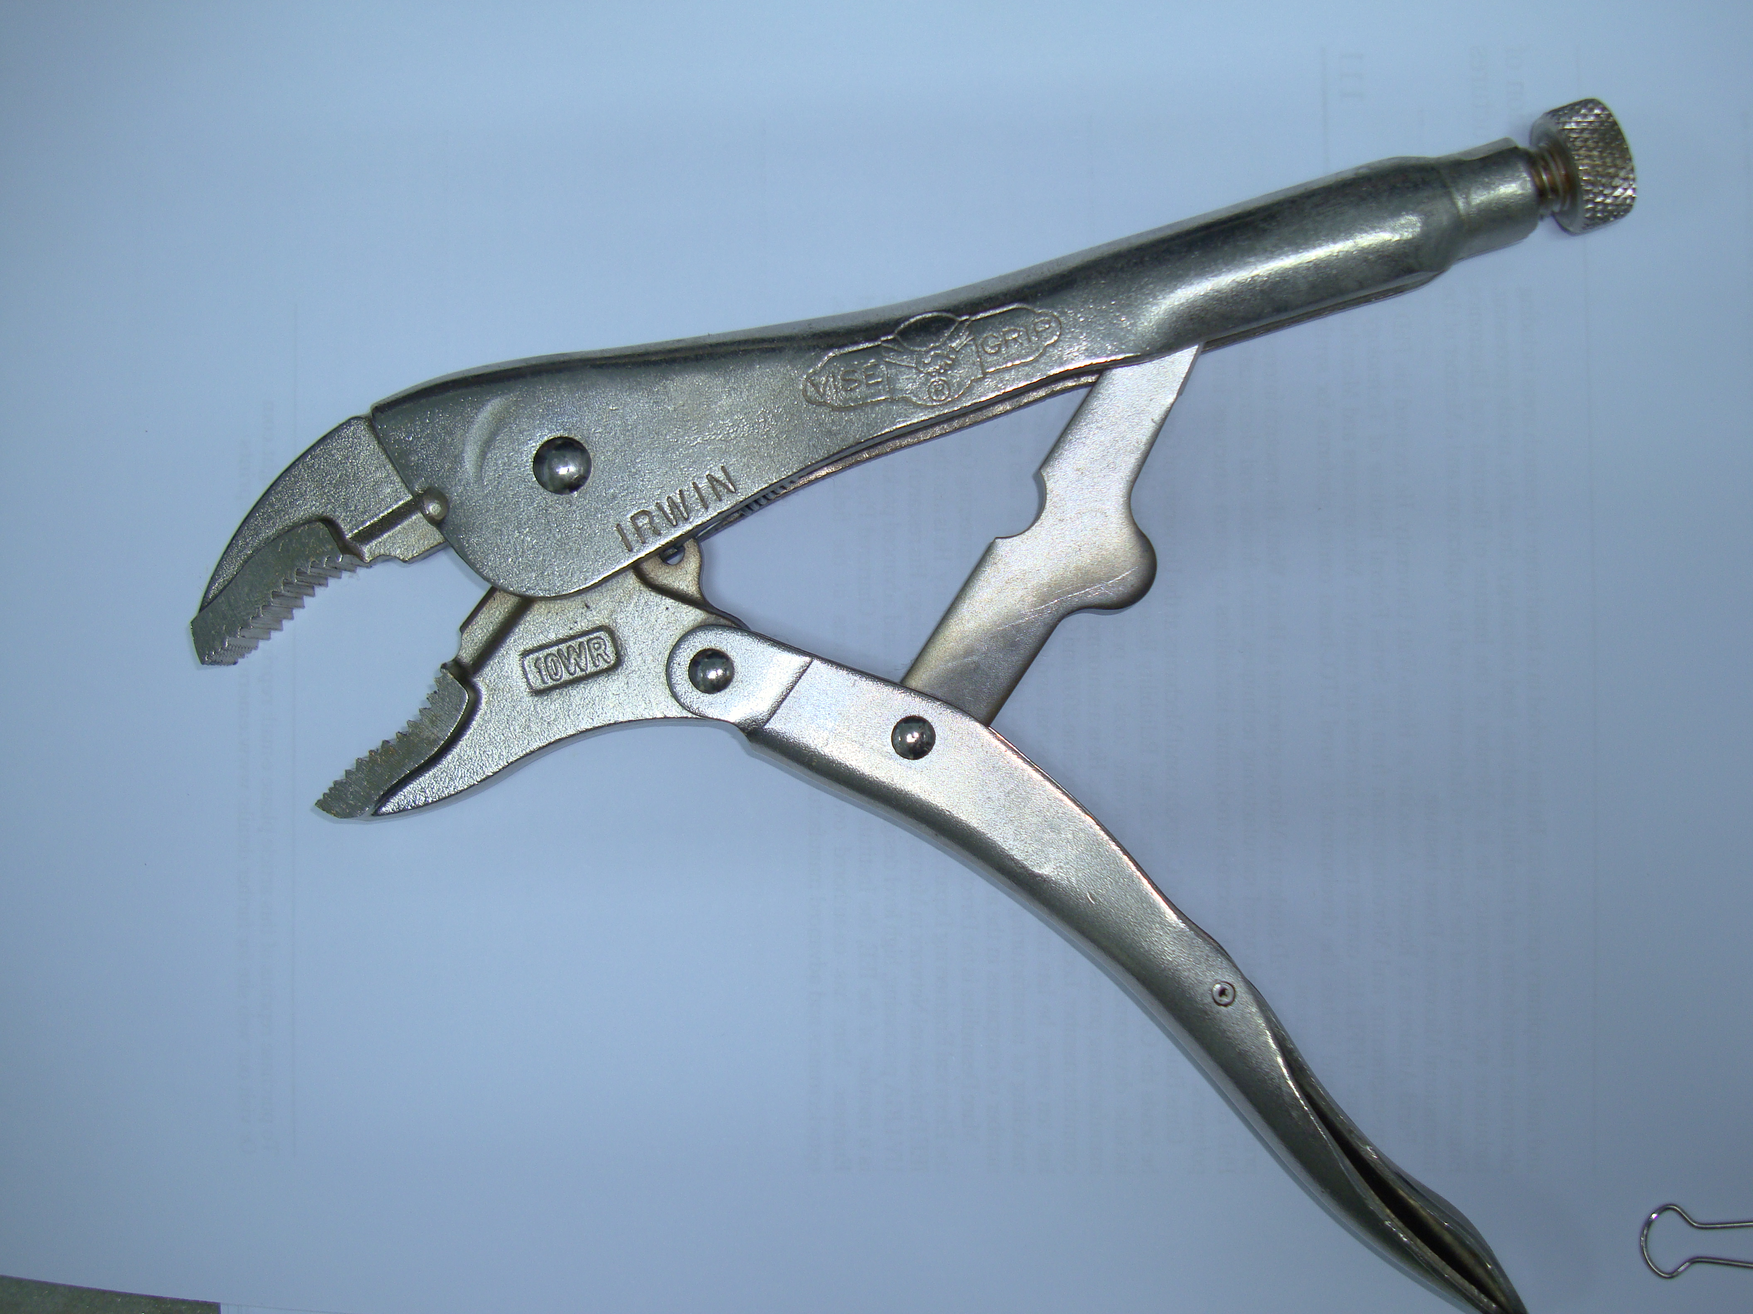

1. (1) The rotating shaft is machined from AISI 1020 CD steel. Please estimate the approximate values of stress concentration factor at Positions B and C, respectively. (8%) (2) The rotating shaft is subjected to a force of F = 6.8 kN. Find the minimum factor of safety for fatigue based on infinite life. If the life is not infinite, estimate the number of cycles. Be sure to check for yielding. (17%)

|  |
| --- |
|  |

1. 有一碳鋼製的圓柱形實心連桿承受一軸向的週期力，該力之最大值為270 kN之張力(Tension)，最小為180 kN之壓縮力(Compression)。該碳鋼的最大張力強度為Su = 690 MPa，降伏強度為Sy = 524 MPa，修正後的耐久極限(Endurance limit)為Se = 182.9 MPa。在忽略安全係數時，請計算欲使該連桿獲得永久壽命(Infinite life)，其直徑至少需若干？使用修正顧德曼理論(Modified Goodman Theory)。(20%)
2. A shaft made of AISI 1020 CD steel having a 40 mm diameter carries a steady load *F* of 10,000 N and torque *T* of 500,000 N-mm is shown in the following figure. The shaft does not rotate. Locate the critical location and determine the principle stresses at the critical location. Is the shaft free from failure? (20%)

|  |
| --- |
|  |